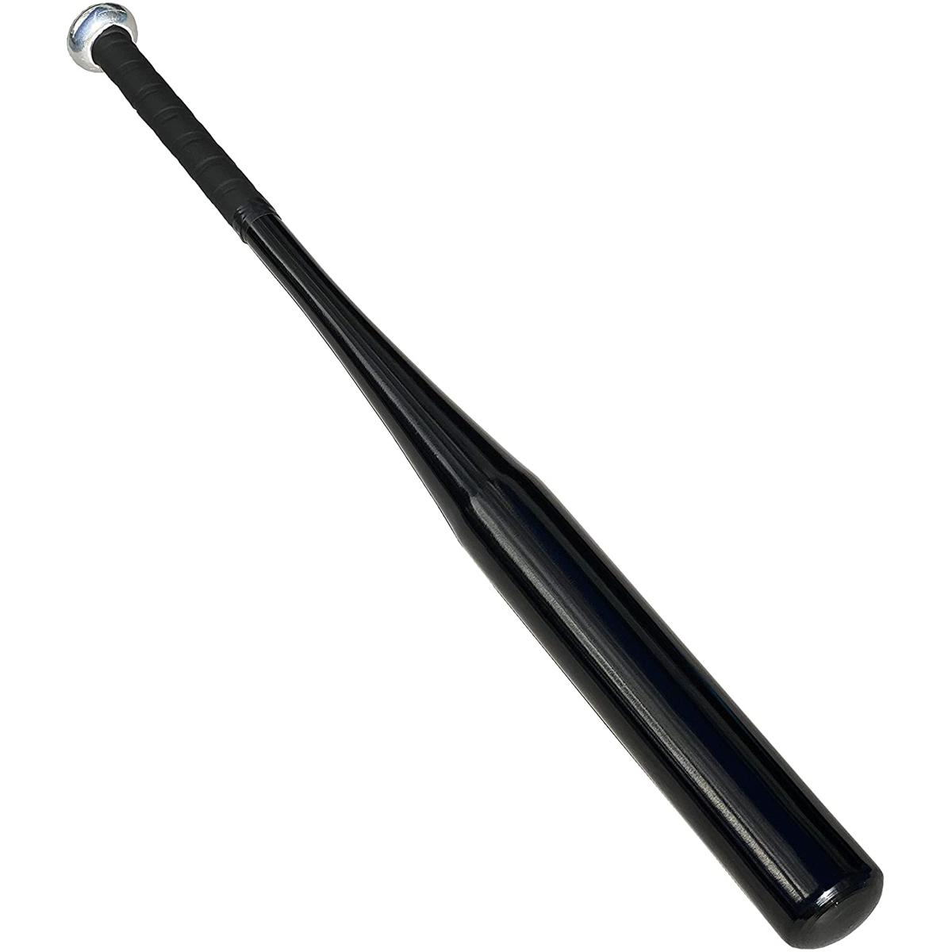

Black Wooden Baseball Bat 30 inches/28 inches

Rs. 699

~~Rs. 1,000~~-30%

* Material : Normal Quality WoodMatt Black ColorUltra Light Weight BatStandard SizeLength 30 inches Use for Multi Purpose Also Played as Gooli Danda

Material : Normal Quality Wood Matt Black Color Ultra Light Weight Bat Standard Size Length 30 inches Use for Multi Purpose Also Played as Gooli Danda